**Windows**

**Output**

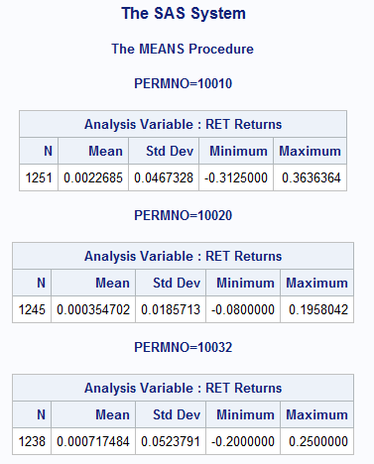

**Code**

/**************************************************

Windows

***************************************************/

options ls=**72**;

libname worklib 'C:\Users\haowang\Desktop\quiz\lib';

*connect to wrds database;

%let wrds=wrds.wharton.upenn.edu 4016;

options comamid=TCP remote=WRDS;

signon username=_prompt_;

*run the sas program on cloud;

rsubmit;

libname crspsd '/wrds/crsp/sasdata/a_stock';

libname crspix '/wrds/crsp/sasdata/a_indexes';

*read data from wrds;

**data** data_stocks;

set crspsd.dsf;

where

(permno=**10010** or permno=**10020** or permno=**10032**) and

**"03JUL1982"d**<=date<=**"30DEC1990"d**;

*download the data from cloud to computer;

**proc** **download** data=data_stocks

out=worklib.data_stocks;

**run**;

endrsubmit;

*compute the average return;

**proc** **means** data=worklib.data_stocks;

by PERMNO;

var ret;

**run**;

**UNIX**

**Output**

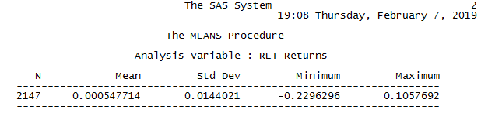

**Code**

/**************************************************

Linux

***************************************************/

libname worklib './data';

libname crspsd '/wrds/crsp/sasdata/a_stock';

**proc** **contents** data=crspsd.dsf;

*read data and store data;

**data** worklib.data_stocks;

set crspsd.dsf;

where PERMNO=**12490** and date>=**"03JUL1982"d** and date<=**"30DEC1990"d**;

keep PERMNO RET DATE;

*compute the average return;

**proc** **means** data=worklib.data_stocks;

var RET;

**run**;